JungChemikerForum – The Federal Board
Emiel Dobbelaar, TU Kaiserslautern – Faculty of Chemistry, Erwin-Schrödinger Str. 52, 67663 Kaiserslautern |  |  | Gesellschaft Deutscher Chemiker e.V.  JungChemikerForum
Emiel Dobbelaar  werbemittel@jungchemikerforum.de |  | Emiel Dobbelaar, M.Sc.  TU Kaiserslautern  Faculty of Chemistry  Erwin-Schrödinger-Str. 52  67663 Kaiserslautern  Mobil: +49 (0) 15772064020  E-Mail: werbemittel@jungchemikerforum.de  Internet: www.jungchemikerforum.de

Order Form for JCF advertising materials and Date:

I, , hereby order the following advertising materials for the JCF regional
group of (You can only order full units):

Unit(s) JCF-Pencils (50 pieces) each 16,50 €: €
Unit(s) JCF-Markers (10 pieces) each 12,40 €: €
Unit(s) JCF-PP-Bags, black (10 pieces) each 9,85 €: €
Unit(s) JCF-Socken (1 pieces) each 7,50 €: €
Unit(s) JCF-Pin(s) (1 pieces) each 0,80 €: €
Unit(s) JCF-Bottle openers (10 pieces) each 9,00 € €
Unit(s) JCF-Poloshirt (1 piece) each 13,90 € €
Please take note oft he measurement table below!
Male cut: x S x M x L x XL x XXL
Female cut: x S x M x L x XL x XXL

-----------------------------------------------------------------------------------------------------------------
Sum (Shipping will be added later): €

Lighters (50 Pcs; Price to be determined after delivery)
Lighters contain hazardous materials and are subject to special shipping requirements. Currently, they can only be delivered at Frühjahrssymposia or Sprechertreffen in a bulk order or picked up in Kaiserslautern. Duly preordering is required.
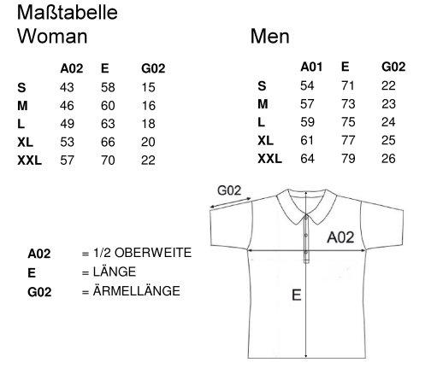
(A02 = ½ chest size, E = vertical length, G02 = sleeve length)
Shipping:
Shipping costs are determined per package
3,79 € (up to 2 kg; 35 x 25 x 10 cm)*
4,49 € (up to 2 kg; 60 x 30 x 15 cm)*
6,49 € (up to 5 kg; 120 x 60 x 60 cm)
9,49 € (up to 10 kg; 120 x 60 x 60 cm)
17,49 € incl. VAT (up to 31,5 kg; 120 x 60 x 60 cm)

Packages up to 5 kg are insured up to 500 € and have the option of shipment tracking.
*If you want a shipping insurance and shipment tracking for a package that weighs less than 2 kg, please indicate so here:

Yes, I wish fort he package to be insured No, I do not want shipping insurance

In this case, the shipping costs are 5,49 €

Please tick / fil in:
I have an idea for new JCF advertising materials Yes No
e.g.

Shipping address:

Billing address (if different):

E-Mail:
Telephone:

Please transfer the amount mentioned on the bill after receiving it via email to the following account:

Inhaber: JungChemikerForum
IBAN: DE73 5007 0010 0096 5889 43
BLZ: DEUTDEFFXXX
Bank: Deutsche Bank
Verwendungszweck: Werbemittel JCF place_bill number

Please only send your orders to werbemittel@jungchemikerforum.de. Orders sent to any other email of mine will not be processed.

